Ahsanullah University of Science & Technology

Department of Computer Science & Engineering

Distributed Database Systems Lab

CSE 4126

Submitted By:

Name: Sifat Ahmed

ID: 15.01.04.144

Group Members:

Abstract

The main theme of Online Grocery Shop Management application is to maintain all kinds of grocery products accordingly with the correct information so that a user can buy his desired products and know when it will be delivered to him and by whom. All of these are managed through a database. The database is divided based on different conditions which are known as fragments and these fragments are kept at different locations which has Database Management System to deal with the data. The idea of dividing/fragmenting the data makes the system reliable, fast with better response. In case of database failures, the system remains functional though it may reduce performance.

Motivation

The idea of the project comes from one of the biggest online market place amazon.com. Amazon the biggest online market place uses their own Distributed Database Management System. With 0.5 billion products selling all over the world, Amazon needs their system to be very fast in case of data insertion and retrieval, reliable, scalable enough to handle increased data volume. Seeing Amazon in real life we tried to implement a smaller conceptual version of Amazon through our project. Though amazon doesn’t share their methods of creating a distributed system, we have made some assumptions on how their system may work in a distributed scenario. Based on our assumption, we try to implement our grocery management system.

Entity Relationship Diagram

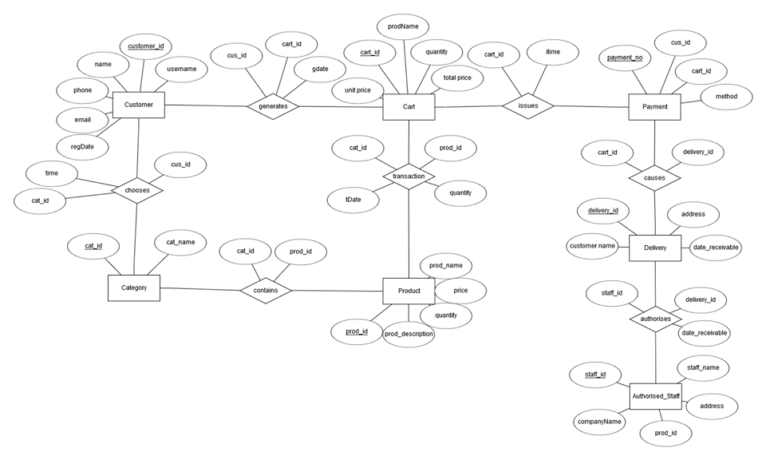

Description

In this project, we tried to implement an online grocery shop system in a distributed manner of the database. For a centralized database, performance, efficiency would have degraded. At the same time any problem in the centralized database might have taken down the whole system. Distributed database has given us an advantage here. In this project we divided data into fragments based on different criteria such as location, type, category etc. and then these data were stored into different sites having same database management system at every site. Here a customer chooses some product and then adds them into cart. After checking out the cart issues a payment and upon confirmation of payment it issues a delivery proposal to the authorized staff to deliver the product in time. Distributed database plays an important role here. For example a staff who delivers product at Dhaka has no need to access the orders of Chittagong or any other place. A customer of Dhaka orders product from the seller of Dhaka, as ordering from Chittagong would be much more. In this manner we distributed data in a way that data access get easier and unnecessary requests for data which increases the cost, makes the system slow can be avoided.

Throughout the project we divided our responsibilities and completed our task to make a demo of the project. The whole project has several phases.

* Creating an Entity Relationship Diagram
* Creating fragments
* Linking up all the sites.
* Inserting data to different sites according to the fragments
* Creating operator tree of the queries and simplification (if needed)
* Creating PL/SQL functions, procedures, control statement, triggers, packages
* Testing

In this project, my responsibilities were creating functions, procedures and triggers which are elaborated below.

Transparency

There are three levels of transparency in distributed database.

* Level 1: Location Transparency
* Level 2: Fragmentation Transparency
* Level 3: Local Mapping Transparency

In Level 3 transparency, location and fragmentation details are available to application user. In our project we divided the data into different fragments and kept them in different locations. Most of the fragmentations were Horizontal fragmentation based on the location of the buyer and seller. These fragments were kept in different sites. For example:

Product1: Select * from Product where Location = ‘Dhaka’;

Product2: Select * from Product where Location = ‘Chittagong’;

Function

* CountCartItems()
  + Usage: Counts the total items in a given cart.
  + Parameters: Cart_ID
  + Return Value: Number of items in the cart.
* GetDateReceivable()
  + Usage: Finds the receivable date or delivery date of a given cart.
  + Parameters: Cart_ID
  + Return Value: Expected delivery date of the cart.

Procedure

* GetProductsOfCategory()
  + Usage: Gets all the products of a given category.
  + Parameters: Category_Id
  + Output: All the products with details of that category.

* ShowDeliveryDetail()
  + Usage: Show the delivery details of a given Cart
  + Parameters: Cart_ID
  + Output: Delivery details of the cart.
* ShowProductDetails()
  + Usage: Show the details of a given product
  + Parameters: Product_Id
  + Output: All the details about that specific product such as name, details, price, availability etc.
* ShowTransactionOfCustomer
  + Usage: Shows all the transaction history of a specific customer.
  + Parameter: Customer_Id
  + Output: Transaction history to the date including total amount, date, quanity of the products.

Trigger

* ProductOutOfStock
  + Usage: Gives a warning if quantity of product goes less than 2.
* ProductAdded
  + Usage: Triggered if product is added into the product table.
* CartGenerated
  + Usage: Triggered when user generates a cart.

Contribution

My part in the project was creating some demo Functions, Procedures and Triggers, though we did everything together. In my part I implemented above mentioned things and explained how these things work to my groupmates so that they understand what I did. And in the same way they have done their responsibilities and explained what they have tried to achieve and how those things work. At the same time we kept the report quiet similar and wrote our parts in the report individually.

Conclusion

The project we tried was based on a real life scenario of how largest online marketplace works. Though we couldn’t implement it as a whole but tried to give an idea how distributed database work in real life scenario. We look forward to implement the project in future on a larger scale.